User Manual – New WMS

logo

|  |  |  |  |  |
| --- | --- | --- | --- | --- |
| **Version No.** | **Release Date** | **Prepared by** | **Reviewed by** | **Approved by** |
| 1.0 | 07-Oct-2021 | Priya Dharshni | Murali |  |
| 2.4 | 03-Nov-2023 | Priya Dharshni |  |  |

Contents

User Manual – New WMS 1

1 Overview 4

1.1 Accessing the Application - iWMS 4

1.2 Login page 4

2 For Project Manager Role 5

2.1 Work Orders list 5

2.2 Create new Work Order 7

2.2.1 For Books 7

➢ Contact Info 7

➢ Job Info 8

➢ Print Info 9

2.2.2 For Journals 9

➢ Contact Info 10

➢ Job Info 10

➢ Print Info 11

2.3 Services tab 12

2.4 Stage tab 12

2.5 Reports 13

2.6 Job Norms Definition master 14

2.7 Checklist Definition Master 16

3. For an Incoming Inspection user 19

3.1 Adding files 20

3.1.1 For Books 20

3.1.2 For Journals-Article 21

3.1.3 For Journals-Non Article 21

3.1.4 For Journals-Issue 22

3.2 View Incoming History 23

4 For a Team Lead user 24

4.1 Assign a task 24

4.2 Reassign a task 25

4.3 File Reordering 26

4.4 Reset option 27

5 For Team Member user 28

5.1 Accessing the Task 28

5.2 Task screen actions 31

5.3 View Task History 32

6 Screens accessible by all users 33

6.1 Work Order Instructions Tab 33

6.2 Graphic Art Tab 34

6.3 File Status Report 35

6.4 Query 37

7. Workflow flowcharts 39

7.1 Role wise workflow 39

7.2 Customer Onboarding workflow 42

8. iWMS user credentials 45

# Overview

## Accessing the Application - iWMS

The iWMS application can be best accessed by either of the below mentioned options,

1. Via CHROME/EDGE browser in WINDOWS and SAFARI/CHROME in MAC by launching the link  <https://iwms.integra.co.in/>
2. By launching the New WMS Thin Client application from the iTools menu. Navigate to iTools -> Software -> General -> New WMS

## Login page

1. Enter the employee ID (ISNO) in the username field and password in the password field. Password is user’s System password
2. Click on the LOGIN button after entering the right credentials to access the iWMS application.
3. If the user is mapped to different DUs he will be able to choose the DU to work on.
4. Once the user log into the application, based on the role and skill mapped the entire menu will differ

**Prerequisites**

1. Make sure the User’s system is connected to the internet.
2. In case the user is working remotely, make sure the system is connected to VPN
3. User should be mapped to a DU and be mapped to the respective Role and Skill
4. The New WMS Thin Client application must be installed for the user machine.

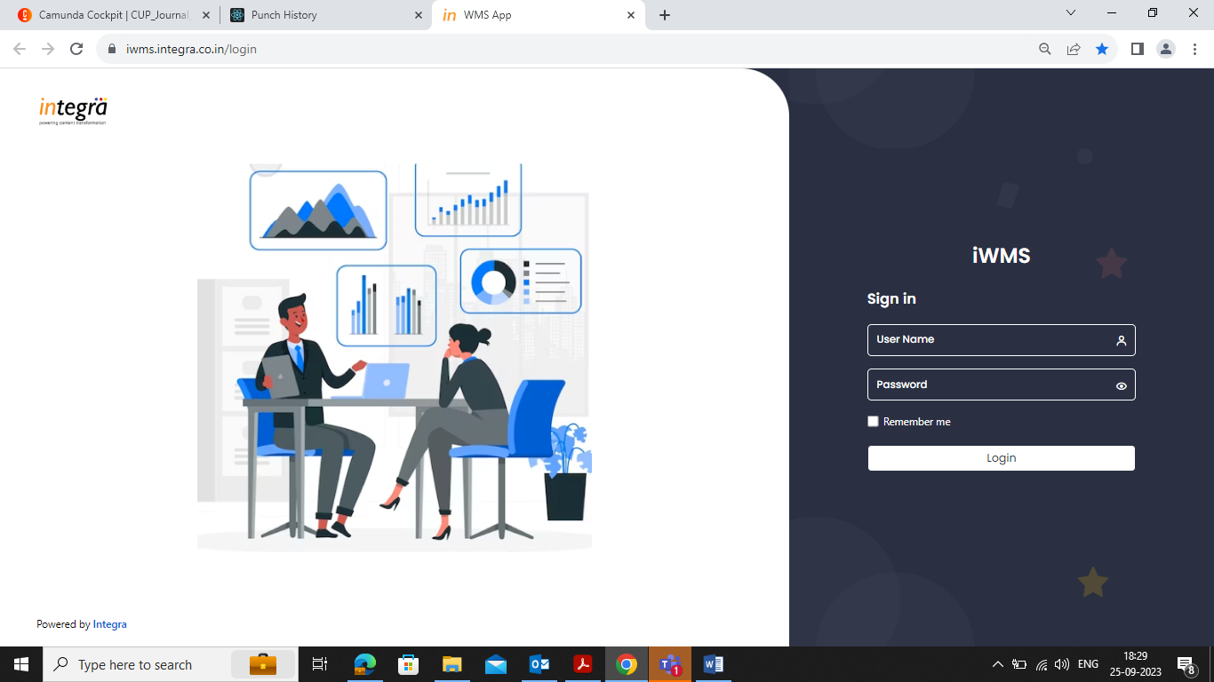

# For Project Manager Role

For the PM, the application will direct the user to the landing page.

Side menu of the application will have the following Menus.

* Work Orders
* Task
* Reports
* Master

## Work Orders list

1. Click on the **Work Orders Menu** to view the existing workorders (Active, Complete and Overdue) list or to create a New Work Order
2. Use the scroll bar to move across the list

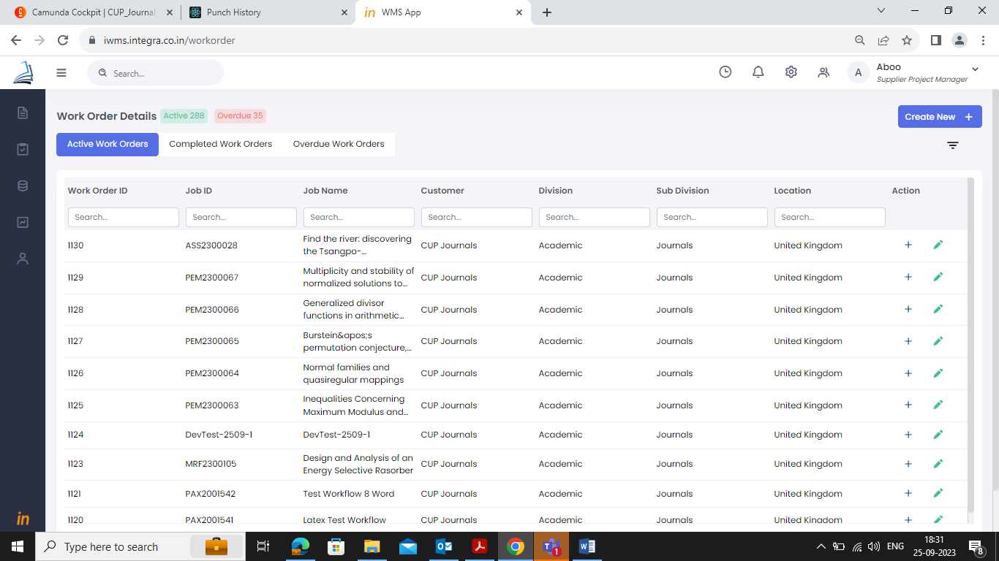

1. To search for a particular work order, use the search filter option provided for each column.

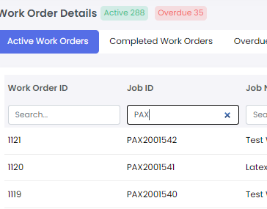

1. Under Action column, Click on the ‘**+**’ button to expand the row which will display the key information tabs (clickable hyperlinks) associated with the workorder.
2. The following menus will be displayed as hyperlinks, Job Info, Service, Stage, File Status Report, Query
3. Click on the required Menu item to go to respective work order tab.
4. Under Action column, click on the **Edit** icon to edit respective work order details.

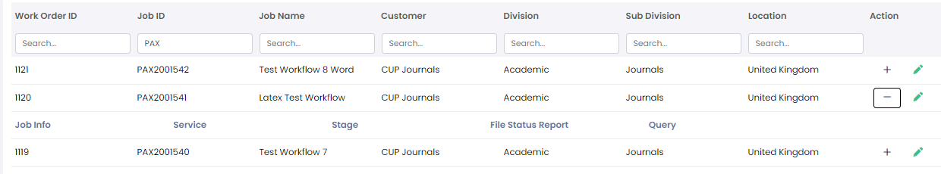

## Create new Work Order

A work order can be created manually or automatically by the WMS system. If the work order creation is automated, the user will still be able to edit work order details using the edit icon in the work orders list page.

### For Books

1. Use the **Create New +** button to create a new Work Order (for manual process). The create new button will open the workorder screens with 3 sections

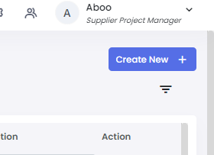

### Contact Info

1. Select relevant data from the drop down provided for various fields.

Select customer, division, sub-division, country from the drop-down fields.

The other fields will get auto-populated based on above mentioned field combination. If there are more than one contact mapped, it will not get auto populated, please select the contact from the drop down provided.

1. If you wish to clear the entered data, click on the **Reset** button.
2. To move to the next section after entering the contact details, click on the **Next** button.

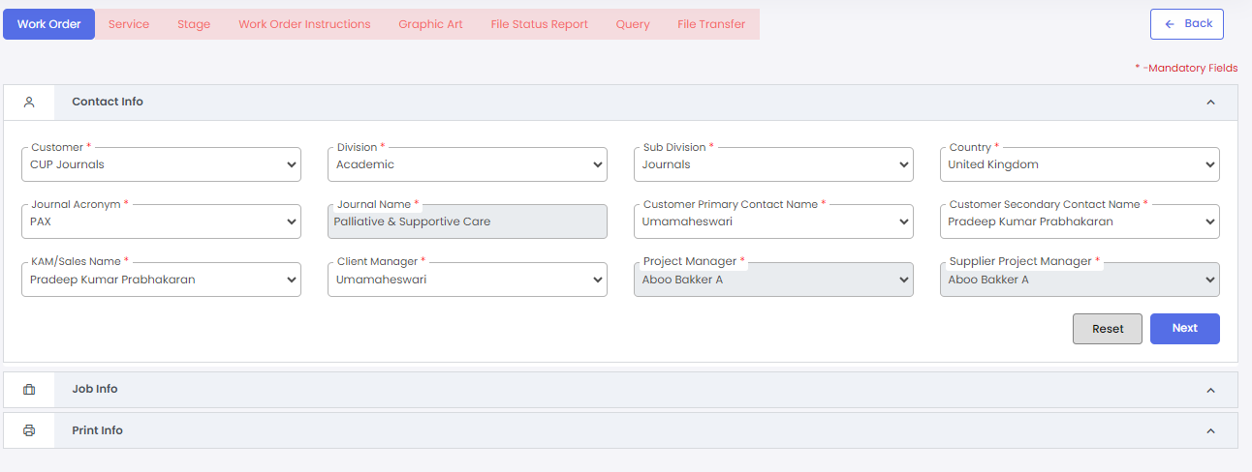

### Job Info

1. Enter Job id and click on the Check Availability option provided below the field to check job id availability. This job id will be the book code for the entire work order. Make sure you enter the right information.
2. Enter job name in the provided field. This is the title of the work order to be created. Make sure you enter the right information.
3. Select the services to be done for this workorder from the drop down provided. If there is only one service mapped to this customer, it will be auto populated or else select required services from the drop-down.
4. Attach order email by clicking the upload icon provided
5. Click on the next to move to next section or previous to move to previous section

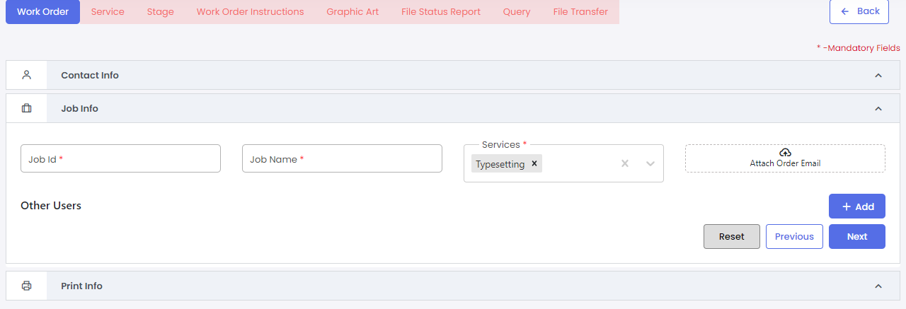

### Print Info

1. Select relevant information provided in the drop down for various fields. This section’s fields are displayed based on customer.
2. Enter the no. of chapters to be worked for this work order.
3. Fill all mandatory fields and click on the save to save all details.
4. Once save is clicked, the workorder will be created.

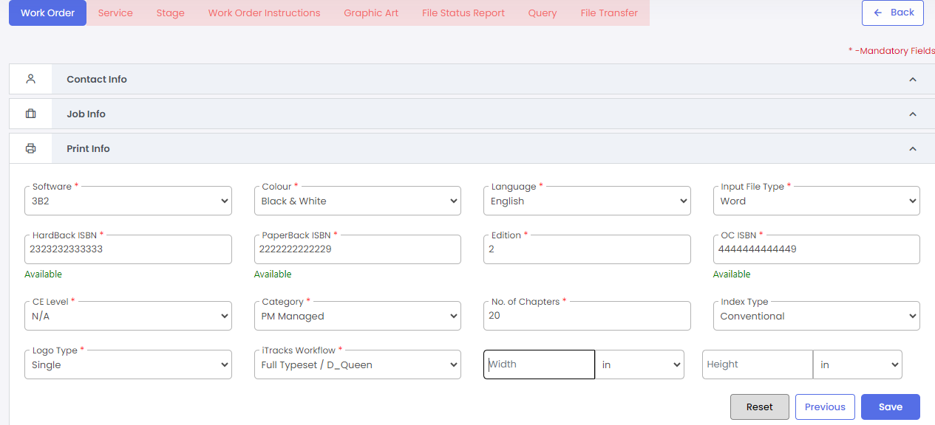

### For Journals

1. Use the **Create New +** button to create a new Work Order. The create new button will open the workorder screens with 3 sections



### Contact Info

1. Select relevant data from the drop down provided for various fields.

Select customer, division, sub-division, country from the drop-down fields.

1. Once the sub-division is selected as journal, the fields related to journal workorder will be displayed.

Select the journal acronym from the drop down provided.

The other fields will get auto-populated based on above mentioned field combination. If there are more than one contact mapped, it will not get auto populated, please select the contact from the drop down provided.

1. If you wish to clear the entered data, click on the **Reset** button.
2. To move to the next section after entering the contact details, click on the **Next** button.

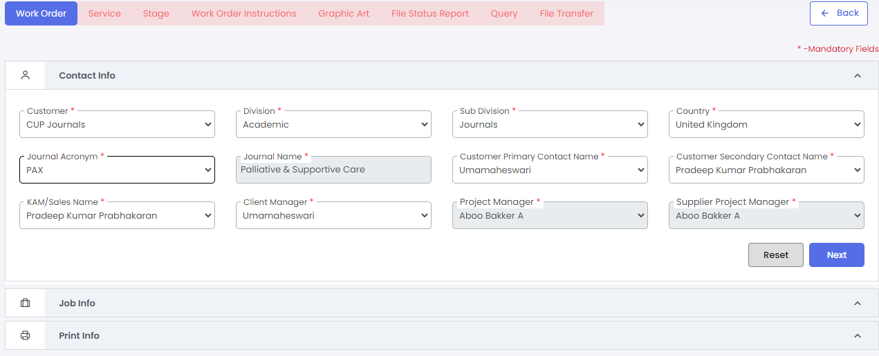

### Job Info

1. Choose the Job type (Article/non-article/issue) from the radio button provided. Other fields in this section will change according to the job type selected.
2. Enter the DOI. Make sure you enter the right information.
3. Enter the Job id. This job id will be the book code for the entire work order. Make sure you enter the right information.
4. Enter the job name in the provided field. This is the title of the work order to be created. Make sure you enter the right information.
5. Select the services to be done for this workorder from the drop down provided. If there is only one service mapped to this customer, it will be auto populated or else select required services from the drop-down.
6. Attach order email by clicking the upload icon provided
7. Other users section will display the contacts mapped to the selected journal. Use the Add button to add more contact details.
8. Click on the next to move to next section or previous to move to previous section
9. For an issue work order, enter the issue number and volume number in the provided fields.

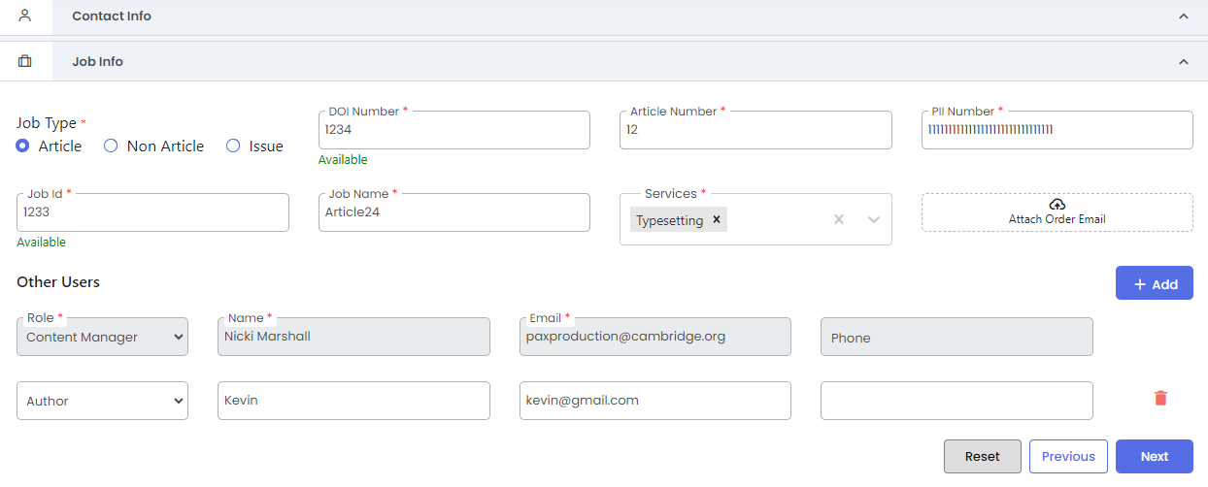

### Print Info

1. The Software, color, language, print ISSN, Online ISSN, Trim size will be auto fetched from the masters based on the journal selected.
2. Choose the input file type and CE Level from the drop down provided.
3. Use previous button to go back to the previous section.
4. Once save is clicked, the workorder will be created.

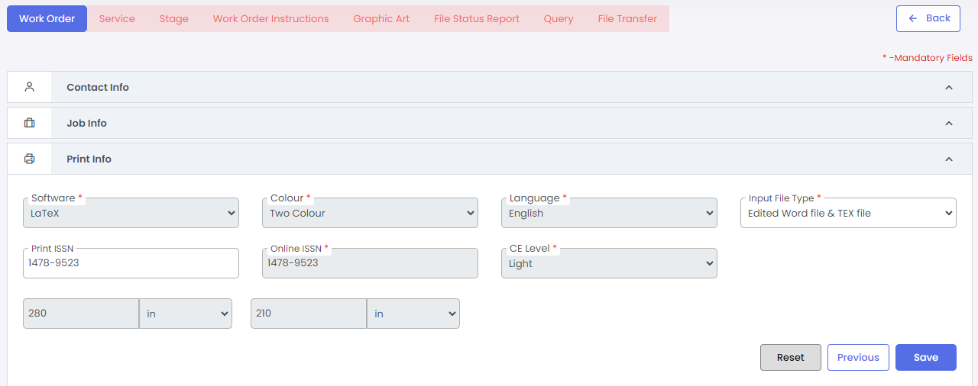

## Services tab

1. Enter all mandatory fields and click on the save icon to proceed.

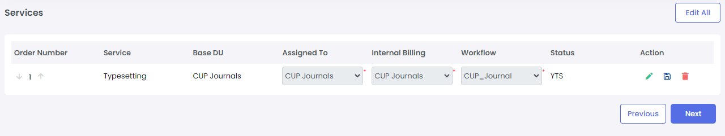

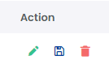

1. Click on the Edit icon to edit the services details
2. Click on the Delete icon to delete the service.
3. Click on the Next to move to next tab.

## Stage tab

1. Click on the Edit icon against each stage row to enter the dates.
2. Enter all mandatory fields and click on the save icon to proceed.
3. When a stage is completed, click on the + icon in the action column to expand the row.
4. Click on the iterate or choose next stage from the drop down provided to move the file to next process in the workflow. When all stages are completed, click on complete button to complete the workorder.

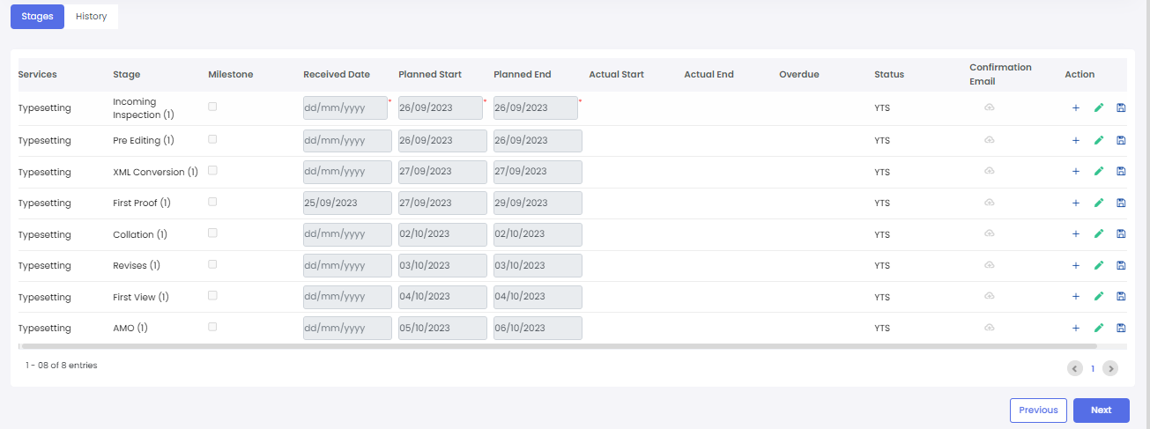

1. Click on the History Tab to view the history of date revisions made for the stage dates.

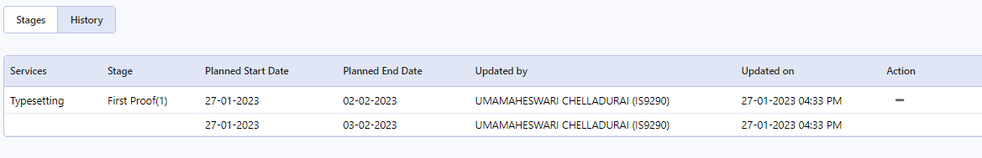

## Reports

1. Various reports can be accessed by the Project Manager from his side menu.
2. Login-> side menu-> Reports-> WIP will display all reports available in the system.

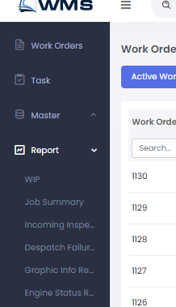

1. User can view different reports by clicking on required reports tab.

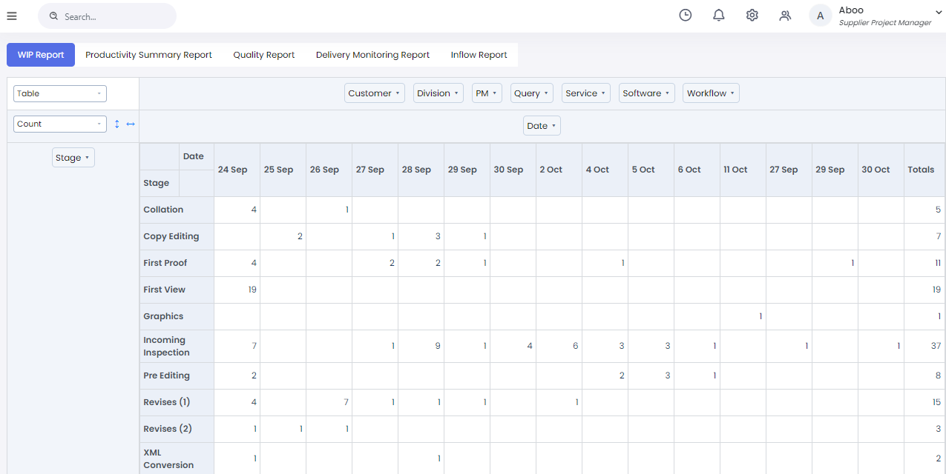

1. Use filters to refine the data based on the requirement.

## Job Norms Definition master

1. Job norms definition master can be accessed by,

Login-> Side menu -> Master -> Norms

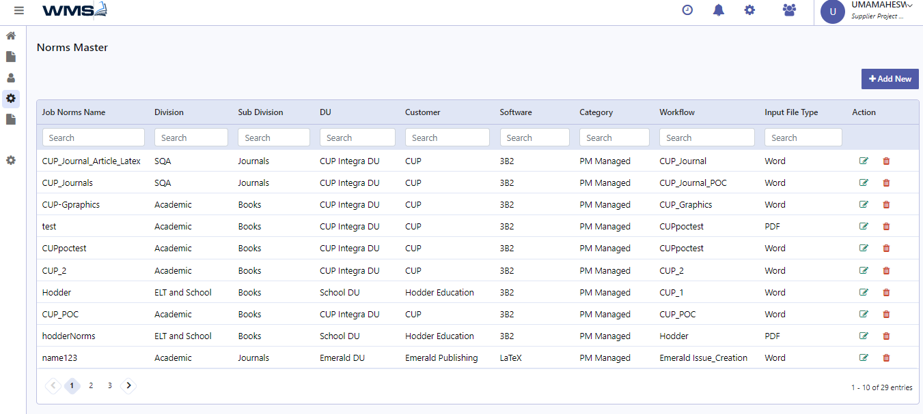

1. Click on the edit icon against each row to edit specific norms details.
2. Click on the delete icon to delete existing norms details.
3. Click on the Add New button to add new Job Norms Definition.
4. Select and enter all mandatory fields.
5. Click on next button to move to next page or cancel to go back to list page.

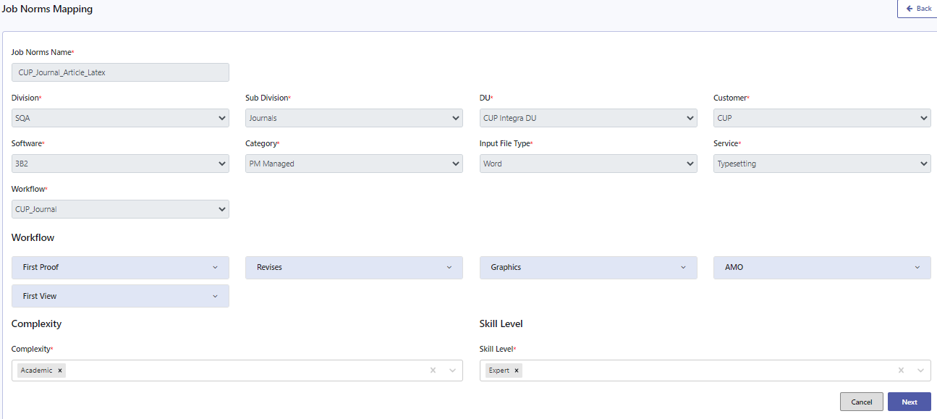

1. Set the values for each activity as selected.
2. Enter all mandatory fields.
3. Click on the copy button in actions column to copy data from another row.

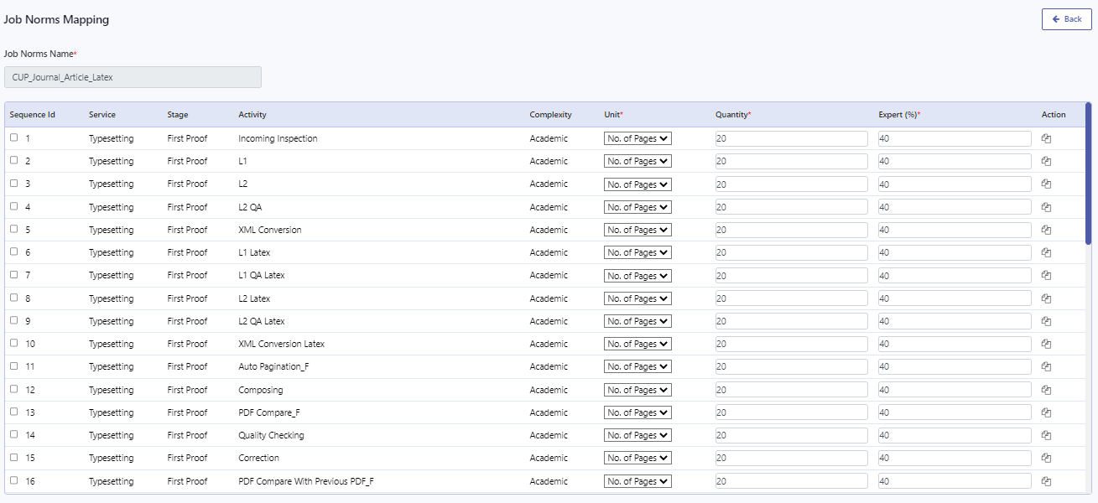

1. Click on previous button to go back to previous screen.
2. Click on the Save button to save Job Norms definition.

## Checklist Definition Master

1. Checklist definition master can be accessed by,

Login-> Side menu -> Master -> Checklist Master

1. Click on the edit icon to edit existing checklist details.
2. Click on the view icon to view the existing checklist.
3. Click on the delete icon to delete the existing checklist.
4. Click on Add New button to add new checklist.

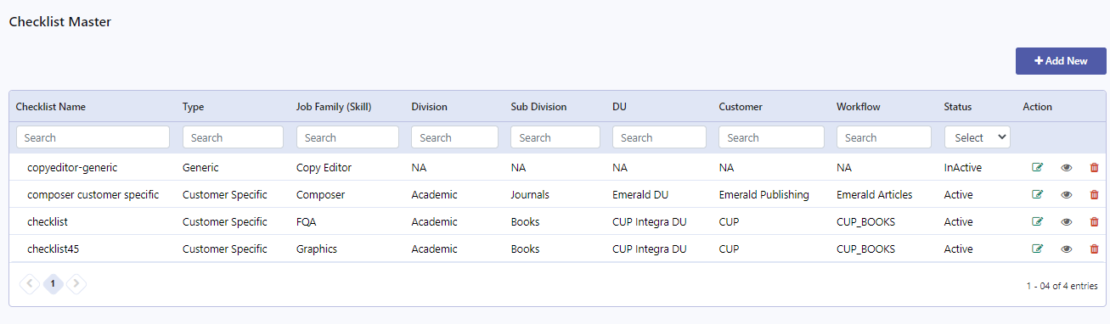

1. Enter checklist name and choose the type of checklist you need to add.
2. Based on the type selection, the form changes.
3. To add a generic checklist, choose the job family for which checklist has to be added.

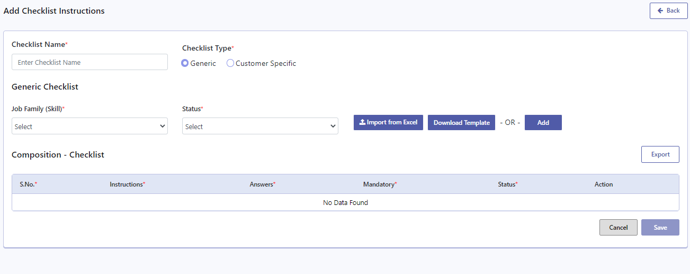

1. Checklist can be added by importing an excel or by adding it manually.
2. Click on download template to download the checklist template.
3. Click on the import from excel button to import checklist.
4. User can also add checklist instruction by clicking on Add button.
5. Enter the instruction, select required fields for each instruction.
6. Click on the save button to save the checklist and cancel button to go back to list page.

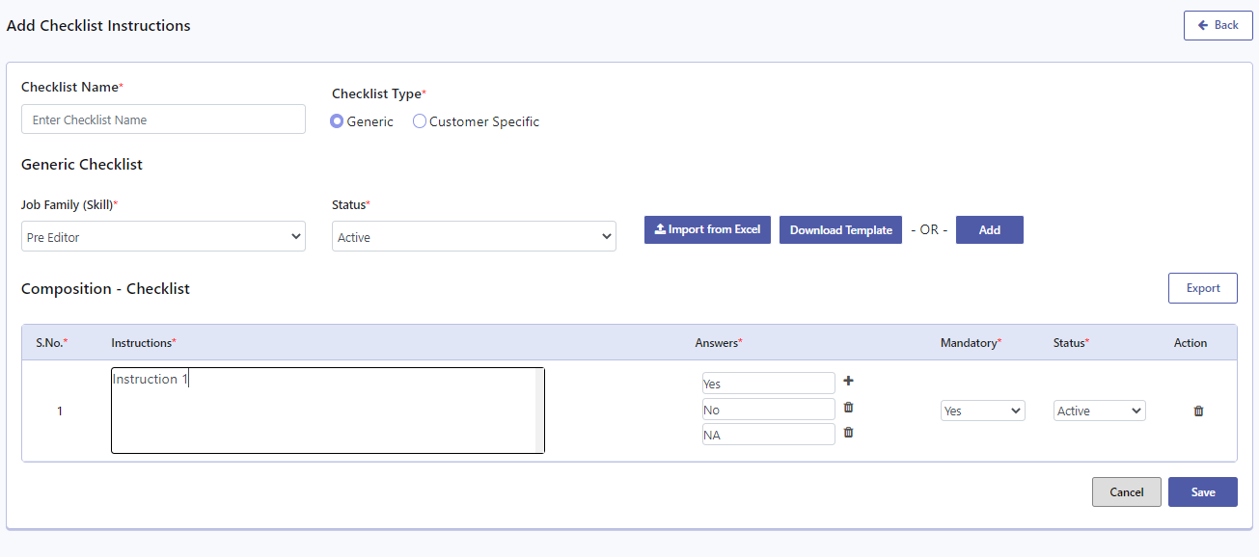

1. To add a customer specific checklist, choose customer specific option in checklist type.
2. Enter all required fields and add checklist instructions.
3. Based on the workflow selected, the stage field will be enabled.
4. User can upload or enter instructions against each stage.
5. Click on save button to save the checklist.

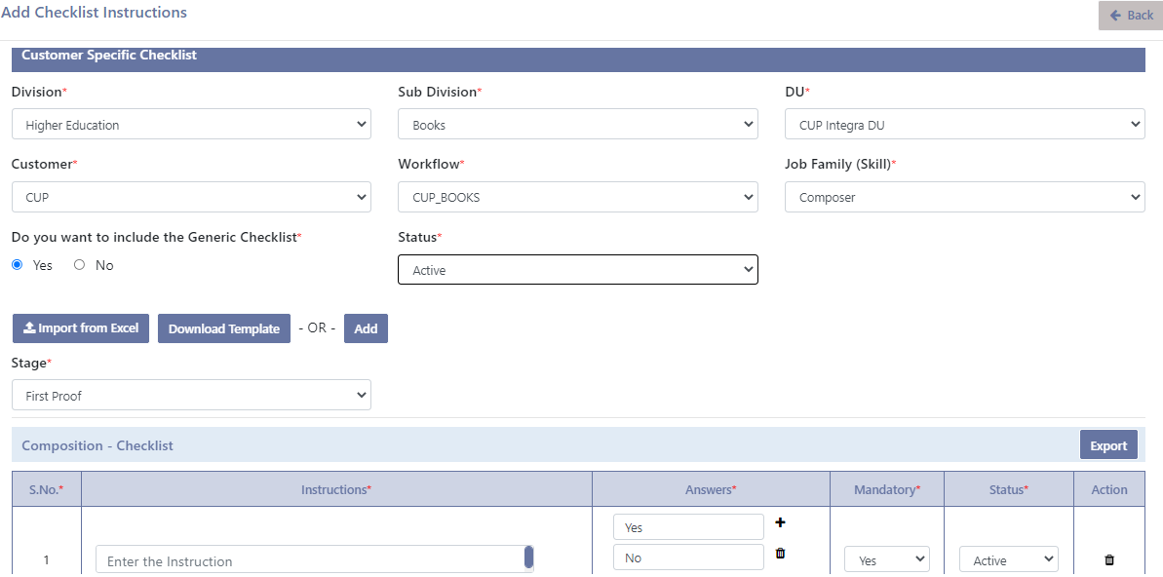

# For an Incoming Inspection user

1. Login with right credentials provided.
2. Click on the Work orders menu from the side menu.
3. Click on the + icon against respective work order to expand the row
4. Click the Job Norms menu from the expansion to go to respective work order’s job norms mapping screen. This is applicable only for Books work order. For a journl work order, user can choose the incoming menu directly.
5. Select the service and workflow for which the job norms mapping has to be done.
6. The norms set for this customer service will be auto populated.
7. Select the complexity from the drop down provided and click on the add button to add it for the service selected.
8. Click on next button to save the job norms and move to Additional Info screen.

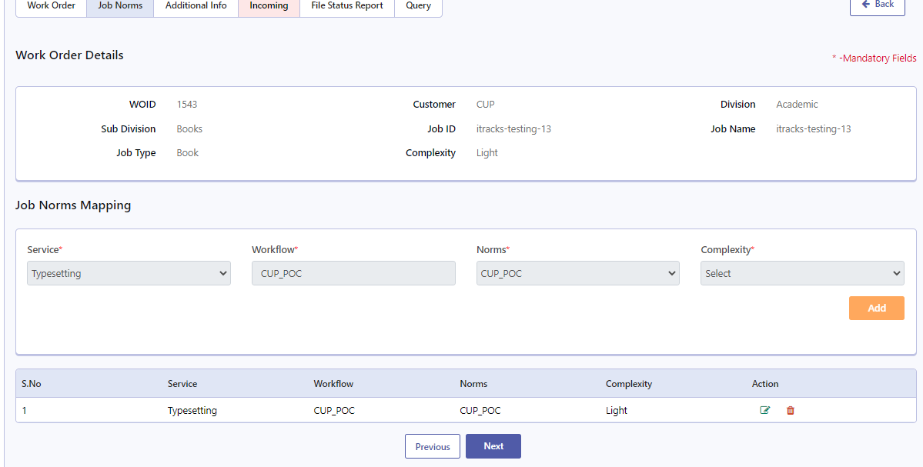

1. Fill all mandatory fields and click on next button to save Additional info for this work order.
2. Click on next button to save the Additional Info and move to incoming inspection screen.

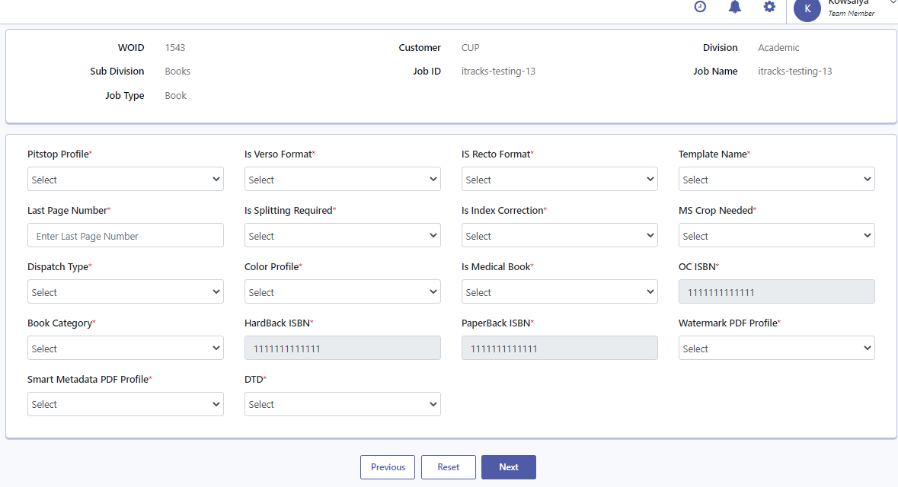

1. User can also click the Incoming menu from the expansion to go to the respective work order’s Incoming page.

## Adding files

### For Books

1. Incoming or template developer can add the template required for this book either by choosing from the provided dropdown or by choosing to upload new template.
2. Click on the **+Add Files** button to select the number of files to be uploaded
3. Select option to upload single or multiple files
4. The rows will be created based on the number of inputs.
5. Use the Edit All or Edit icon across individual row item to edit the chapter details.
6. Use upload icon to upload the files.
7. Choose respective file type against each file added.
8. Enter all required information for each chapter (ms pages, est pages, images, etc)
9. If number of images is provided, graphics will be enabled for this work order.
10. Click on the Update All or Save icon to save the changes made.

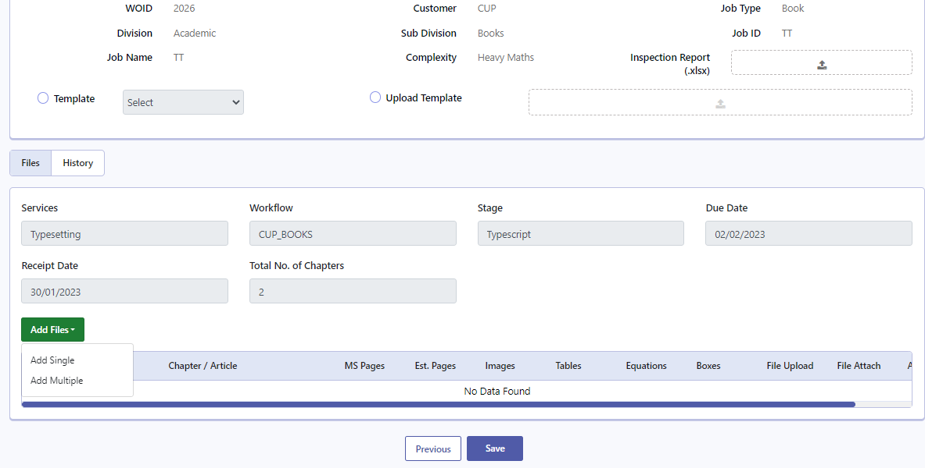

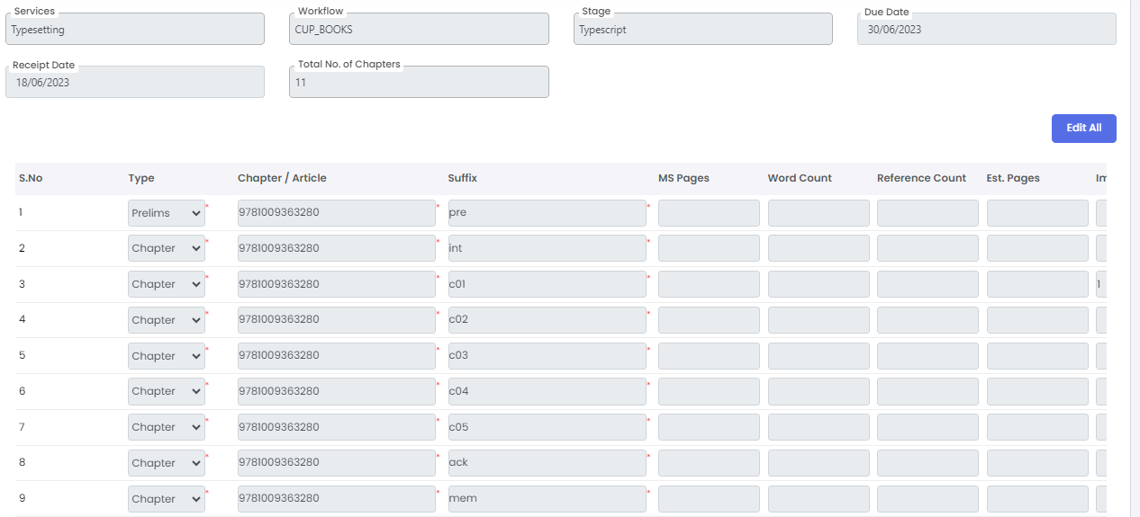

### For Journals-Article

1. By default, one row will be displayed with the file upload icon.
2. Click on the upload icon to upload the file.
3. Click save icon to save file details.
4. Click on Save icon to save the changes made and finish incoming.

### For Journals-Non Article

1. By default, one row will be displayed with the file upload icon.
2. Click on the upload icon to upload the file.
3. Click save icon against the row to save file details.
4. Click on Save icon to save the changes made and finish incoming.

### For Journals-Issue

1. Click on Add Articles to Issue button to add articles and non-articles to the issue.

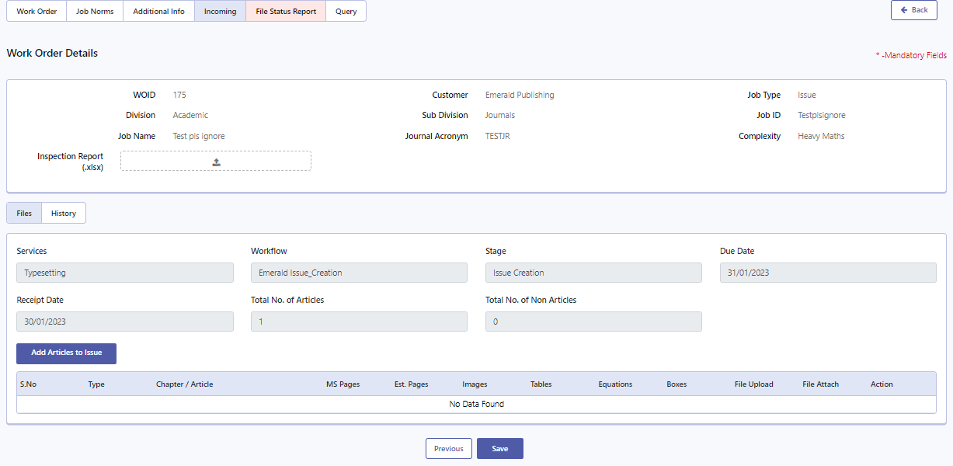

1. Select the required articles and non-articles from the unassigned list and click on add button to assign it to the issue.
2. Click on save button to save the issue.

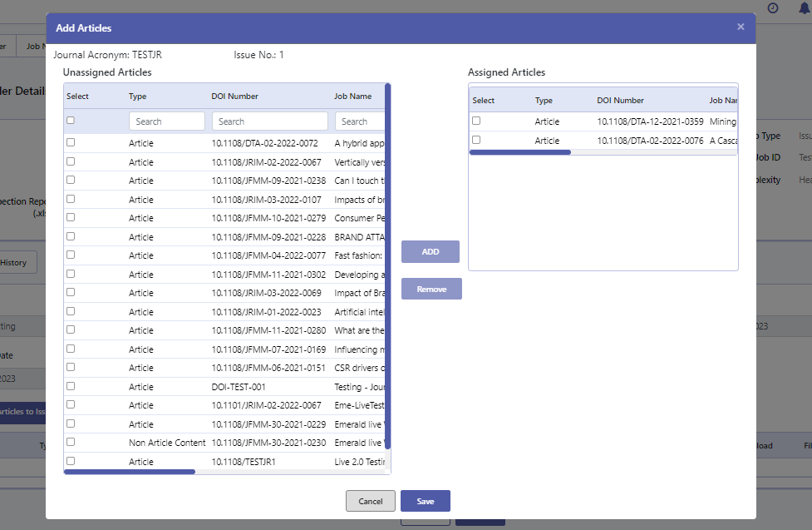

1. If you want to remove the added articles/ non-articles, click on delete icon against each row to unassign it.
2. Click on the save button to save all changes and finish incoming.

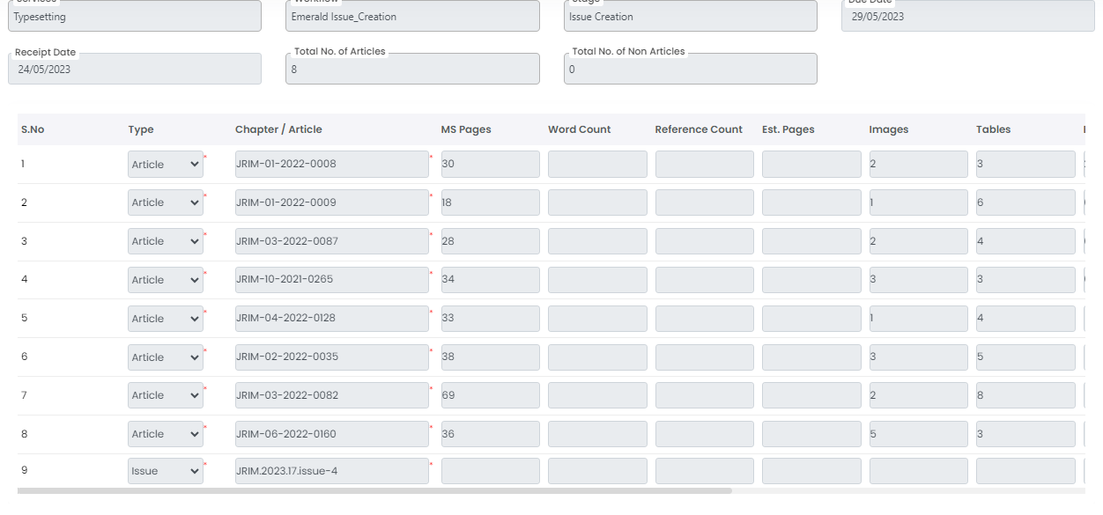

## View Incoming History

1. Click on the history tab to view the history of file upload done in incoming.
2. Each row item is a slot. Click on the slot id (provided as hyperlink) to view that particular slot details.
3. Click on the Export option to export that slot data.

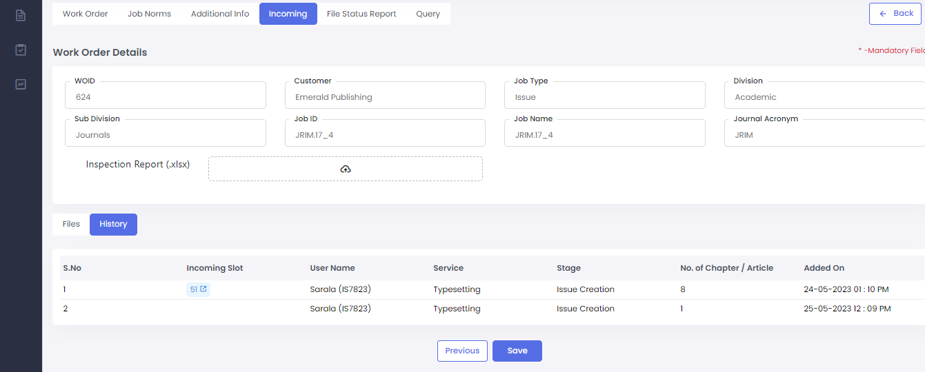

# For a Team Lead user

1. Login with right credentials provided.
2. Click on the Task menu from the side menu provided
3. View Unassigned, Assigned, Completed tasks tabs. Use scroll to move across the list.

## Assign a task

1. The unassigned tab will display all available tasks that are not yet assigned or claimed.
2. In Unassigned Tab, click Assign button to assign a task to a user

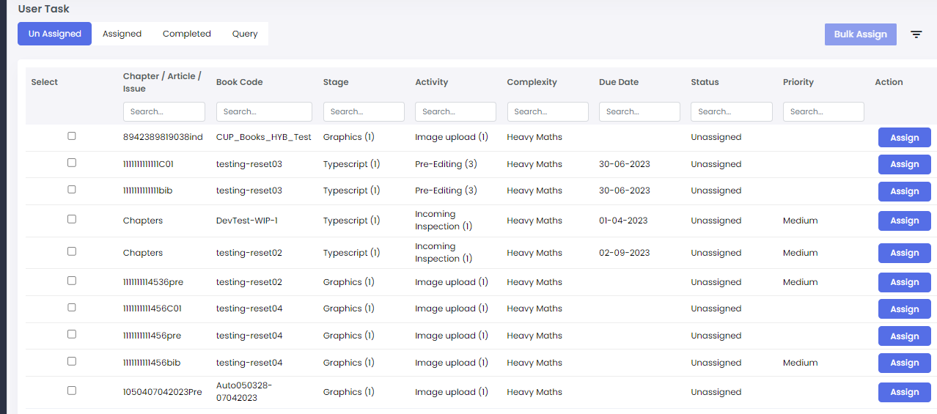

1. Select employee name from the drop down, set priority and date and click on the assign to assign the task to the selected user.
2. To bulk assign, select two or more activities and click on the Bulk Assign button to assign multiple tasks to a selected user.

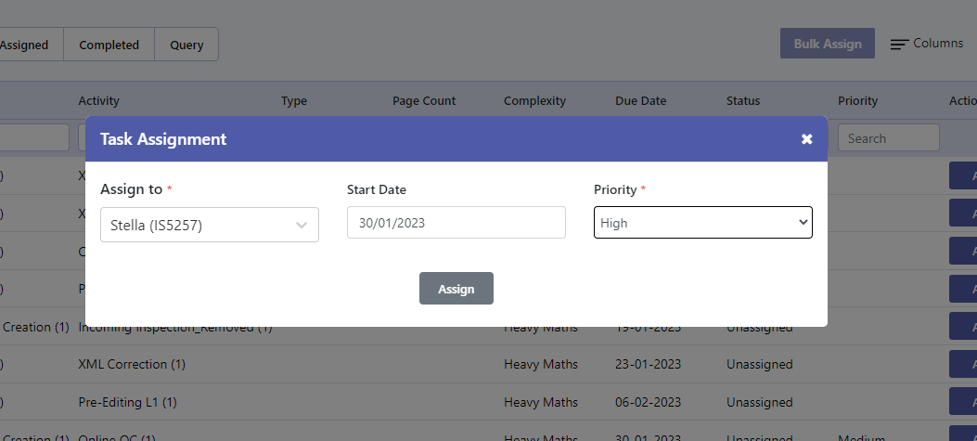

## Reassign a task

1. Click on the Assigned Tab to view the already assigned tasks. Click on the Reassign button to reassign task to a different user.
2. Click on the Bulk Reassign to reassign multiple tasks to a different user.
3. Click on the Edit UOM button to edit UOM information for that particular task.
4. Click on the Completed tab to view the completed tasks.

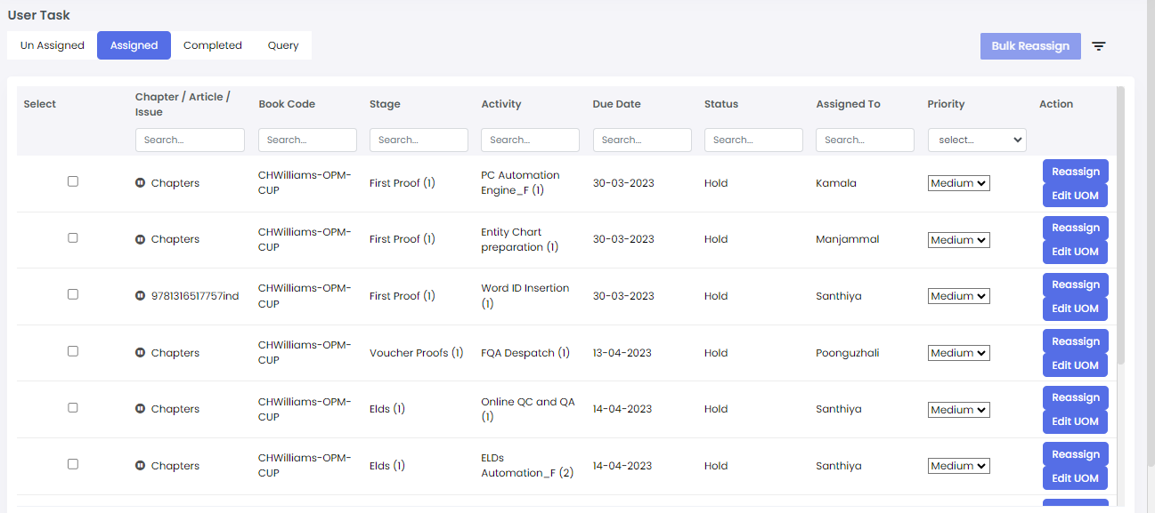

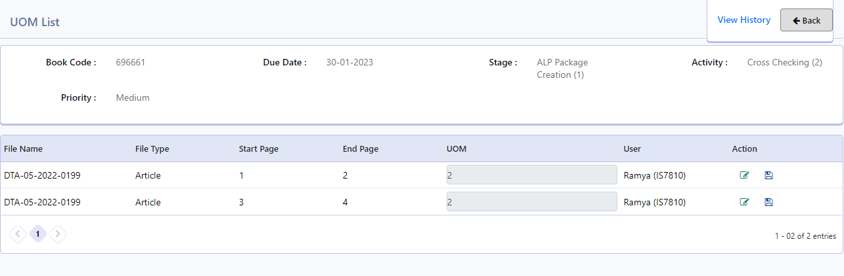

## File Reordering

1. File reordering menu will be available for the team lead in the File status report for each work order.
2. The interface will list the chapters in the work order.
3. Click the action icons provided (up, down, drag) to move the files accordingly.
4. Click on save file ordering button to save the changes made or cancel to close this action.

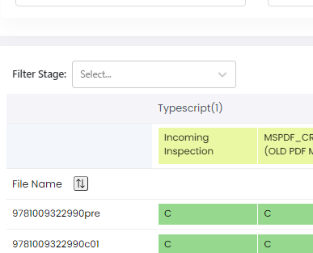

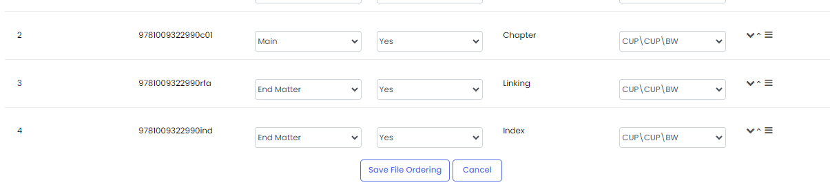

## Reset option

1. Reset option will be available for team lead under work orders expansion menu for each work order created.
2. In the reset interface, choose the service, stage, activity to be reset.
3. Choose the chapters to be reset using the checkbox provided.
4. Enter the reason for reset to be made.
5. Click on reset button to finish the reset process.

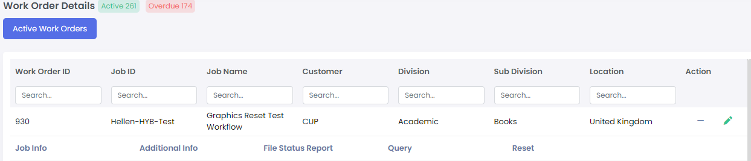

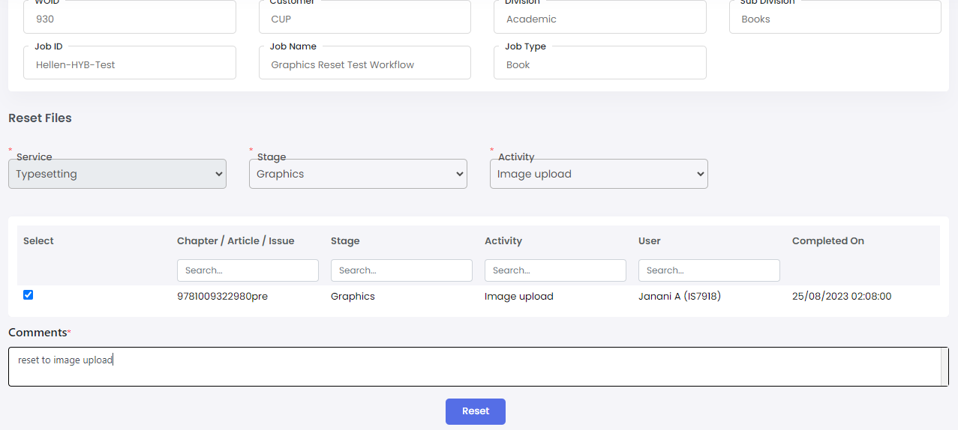

# For Team Member user

## Accessing the Task

Before beginning a task, make sure that the latest version of iwms client utility is installed in your system. This is required only if the application is accessed through web browser.

1. Login with right credentials provided.
2. Click on the Task menu in the side menu to view All Tasks and My Tasks tab. Use the scroll to move across the list

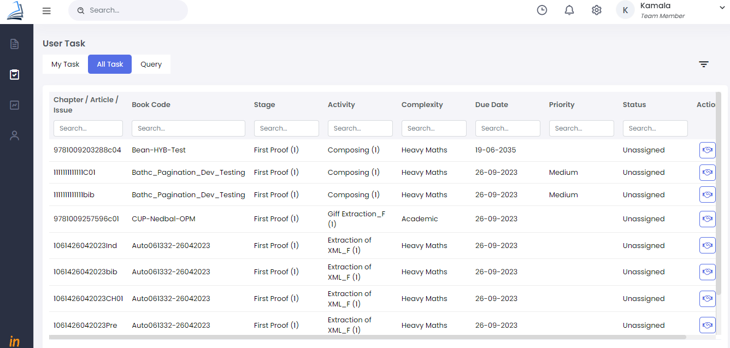

1. Click on the My tasks tab to view tasks assigned by team lead or claimed by yourself
2. Click on the View button to enter the task screen
3. In All Tasks tab, click on the Claim button to claim and view the task screen
4. Once user claims/ view the task, the local working folder with all associated files will be opened. If there is a client utility version update, user has to click on download all to open the working folder.
5. The files associated with the task will be listed in the files to process column, if there are multiple files, click on the file name (provided as hyperlink) to view the sub files of that article below in the file details section.

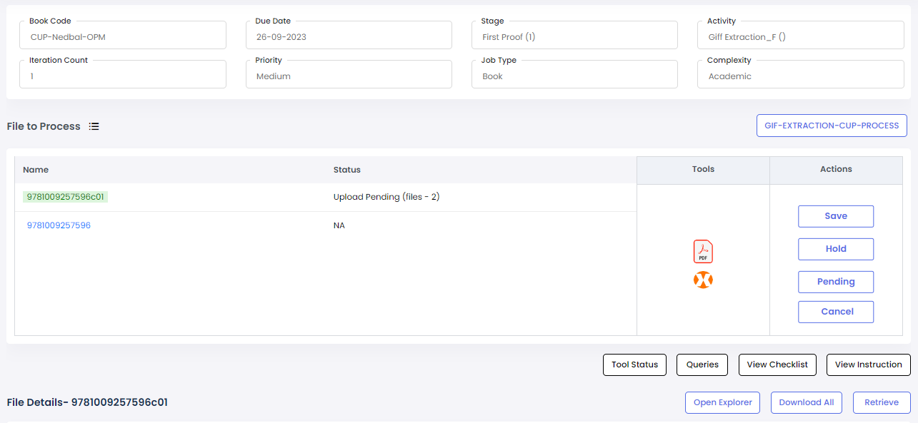

1. Hover the cursor on Upload Pending status to know the list of files need to be uploaded.
2. Click on the Download All button to Downloads all the file required for this particular activity into the local working folder (the iwms client utility will create a working folder in the user system)
3. Click on Open Explorer button to open the empty local working folder.



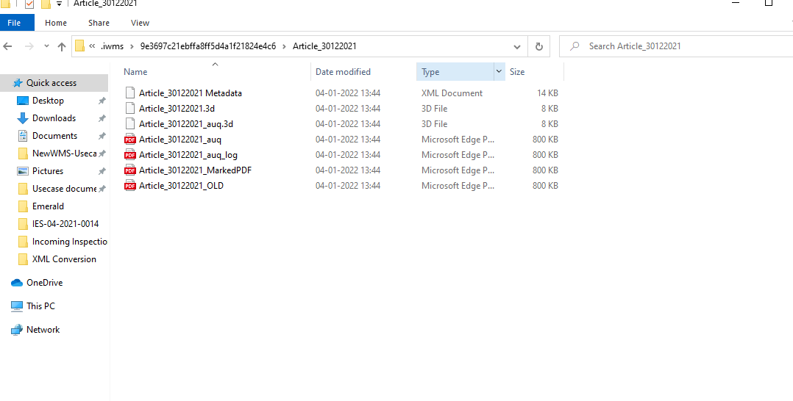

1. The tools configured for that activity will be listed in the top of files section. Click on required tool button to run that tool.

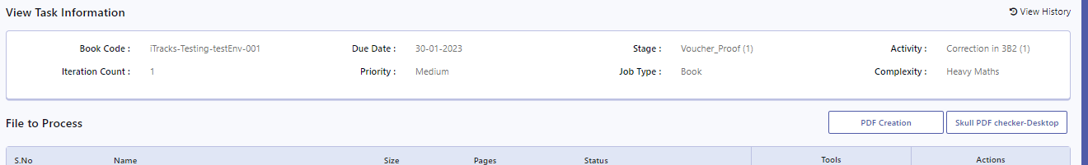

1. Work on the files in your local system and upload the required files in the local working folder created by iwms client utility.
2. Close the working folder and click on save to sync all files and complete the task.
3. To open particular file, double click on the file name in the files details section or use the tools icon in the tools column to open all files associated to that tool.
4. The explorer icon against each row will open the working folder in the file path of the selected file.

## Task screen actions

1. Click on the View Instruction button to view respective work order instructions added.
2. Click on the View Checklist button to answer instructions and to complete the checklist before saving the task.
3. Click on Retrieve button to view and download the production backed up files for this activity. This retrieve will replace the selected file from the local working folder.
4. Click the Save /Hold/Pending/ Reject actions to complete the task process.
5. Click the Cancel button to undo any changes made to the task and to go back to my task screen.

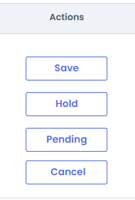

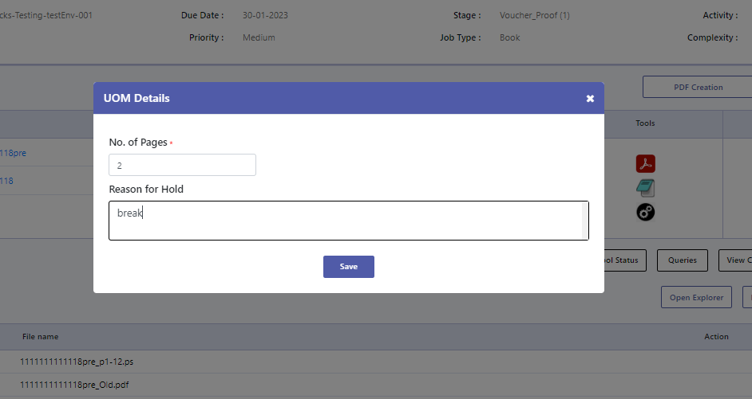

1. After uploading all required files, click on the save button to save and complete the task.
2. If there is an UOM validation error, contact the respective Team Lead to get it sorted.
3. To put a task on pending, click on the pending under save button. Enter no. of pages and click on the save.
4. If there are tools included in the activity, click on the required tool button to execute the tool.



1. User can view the status of tool execution by clicking on the tool status button.
2. Refer to the remarks column to access the output of the tool execution.
3. Click on close button to close the tool execution status table.

## View Task History

1. Click on the View History to view the history of this task across different stages.
2. Click on the task name hyperlink to view the audit trail details of that activity.
3. Click on the files tab to view the files associated in that activity.

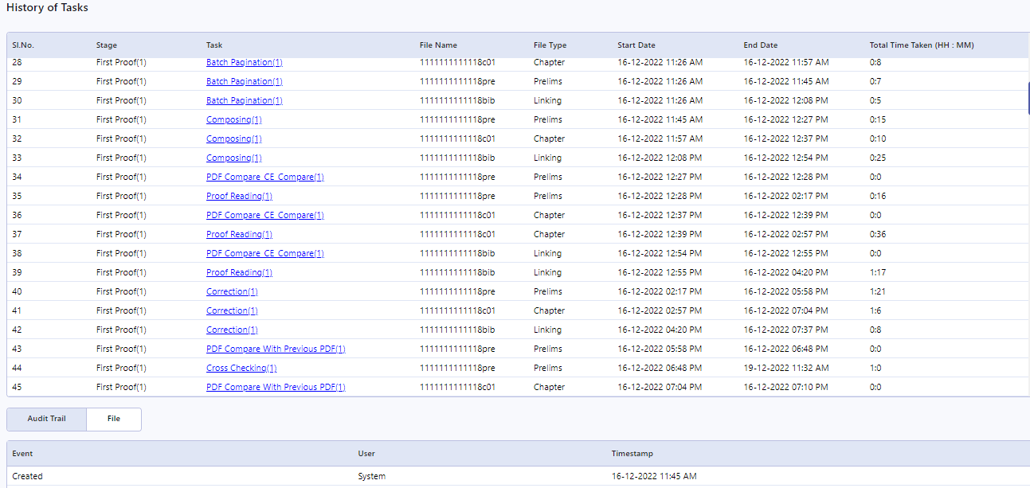

# Screens accessible by all users

## Work Order Instructions Tab

The Work Order Instruction Tab can be accessed by clicking the expansion icon against each work order in the work order list.

The work order instruction tab will have view only access to team lead and team member users.

The project manager and incoming inspection users will be able to edit and view the work order instruction.

1. Click on the **Add** button to add instruction to the workorder
2. A pop-up will open, select service and stage from the drop down provided.
3. Enter the instructions in the field provided or upload instruction files by clicking the Add Files button.
4. Click on the Save to save the instruction for the selected service and stage.
5. Click on the **Edit** icon to edit the uploaded instruction
6. Click on the **View** icon to view the uploaded instruction

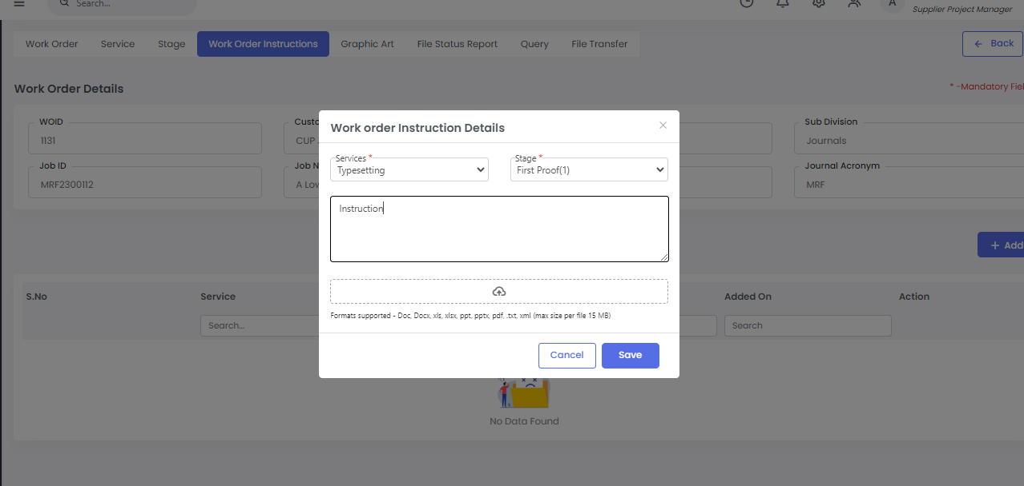

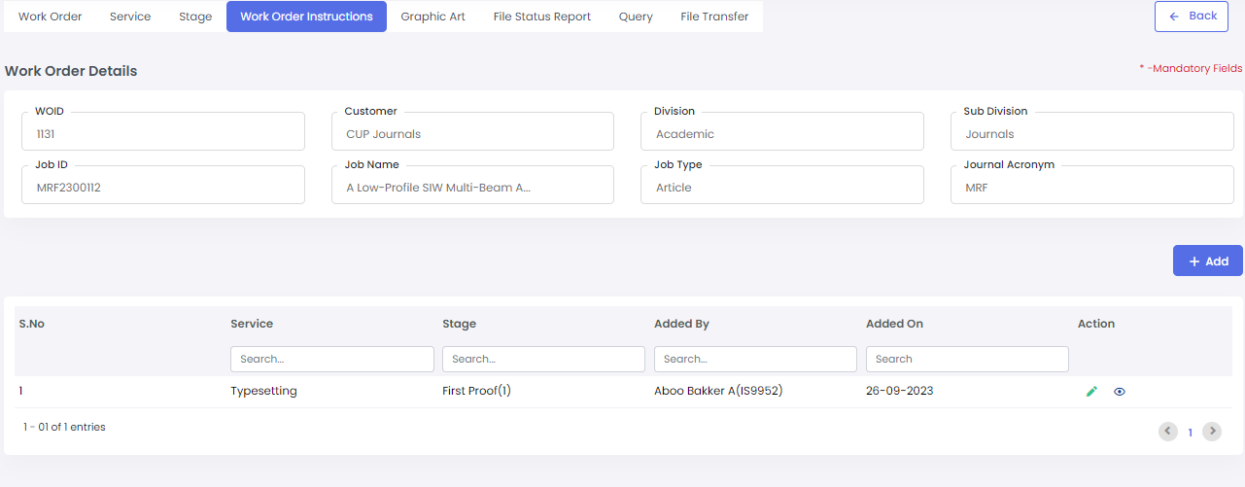

## Graphic Art Tab

1. The Graphic Art Tab can be accessed by clicking the expansion icon against each work order in the work order list.
2. The Graphic Art tab will have view only access to Incoming inspection, team lead and team member users.
3. The project manager will be able to add/edit and view the Graphic Art files.
4. Click on the Edit icon against each row to get the Upload button enabled.
5. Click on the Upload button to upload files for the respective service/ stage
6. After upload, click on the save icon to save the uploaded file
7. Click on the Download icon to download the file.
8. Click on the Audit Trail tab to view the history of file upload.

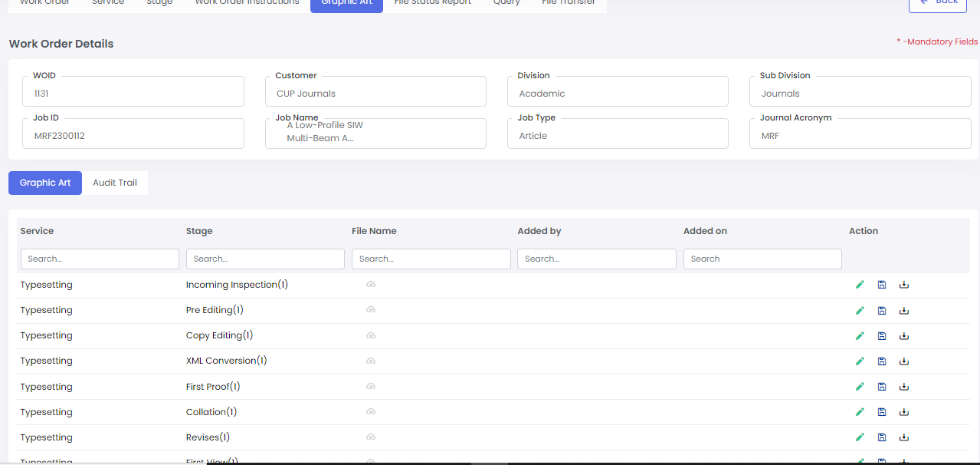

## File Status Report

1. Task status report can be accessed by all users from the Work orders list screen under the expansion menu.
2. Login -**>** Work Orders -> click on the + icon against respective work order -> click on the Task Status Report menu under expansion.
3. It can also be viewed by clicking the report icon from header section of the application. User can search for a job ID and look the report.

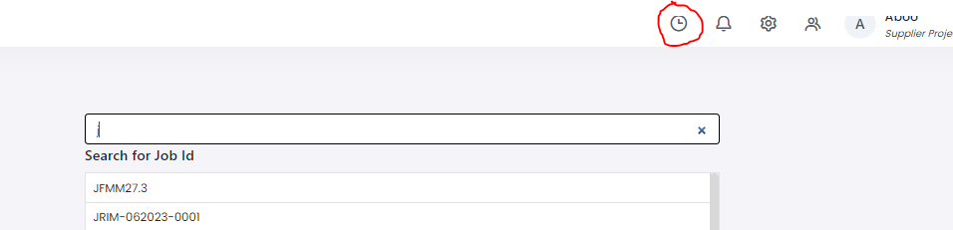

1. Click on the status cell to view the details of chapter/ article/ issue in that stage and activity
2. All users (project manager, incoming inspection, team lead, team member) will have view access to File Status Report
3. Click on the Files tab to view and download the output files uploaded by the user in that activity and stage.
4. Click on Process Adherence tab to view the summary of Checklist instructions completed by the user for that task.

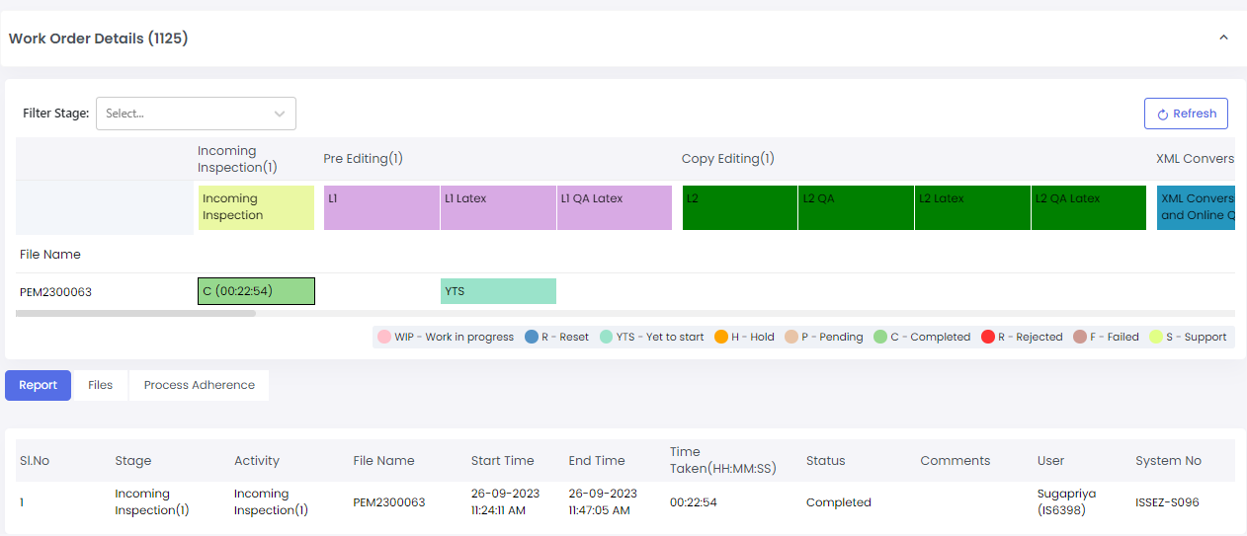

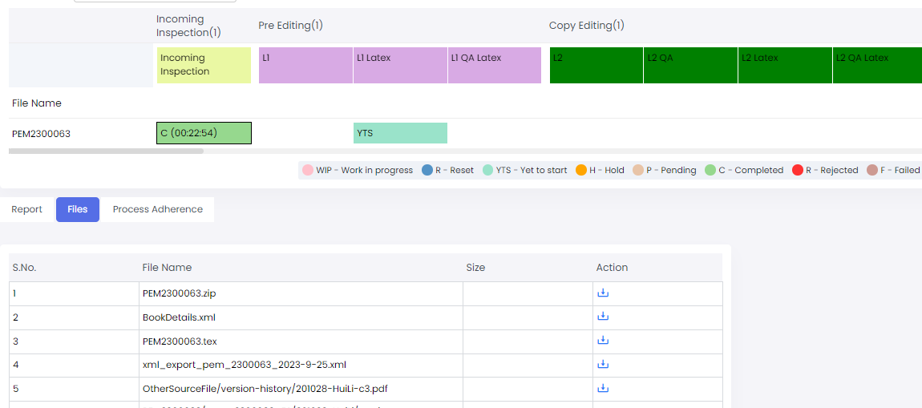

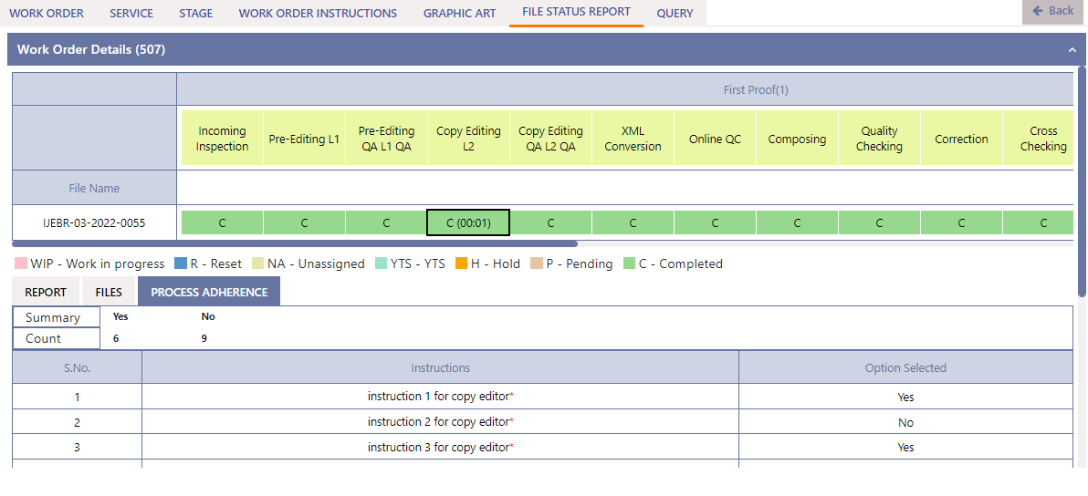

## Query

1. Query tab can be accessed by all users from the below mentioned screens

* Work orders list screen under the expansion menu.
* Query tab in User Task List screen
* By clicking the Queries button on View Task Information screen.

1. The query tab in work order screen will display all the queries raised for that work order.
2. The query tab in View Task Information screen will display all queries assigned to the skill of the logged in user.
3. Click on the view icon to view the query summary.

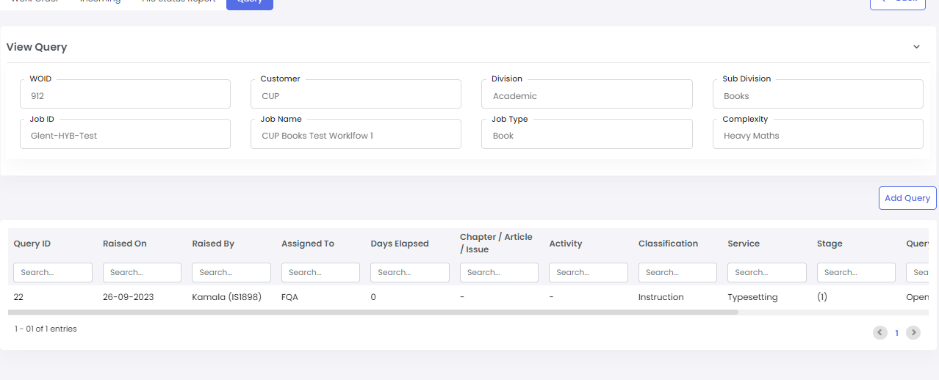

1. Click on the reply button to respond to the query.
2. Use the text box to respond to the query.
3. Click on submit to submit query response.

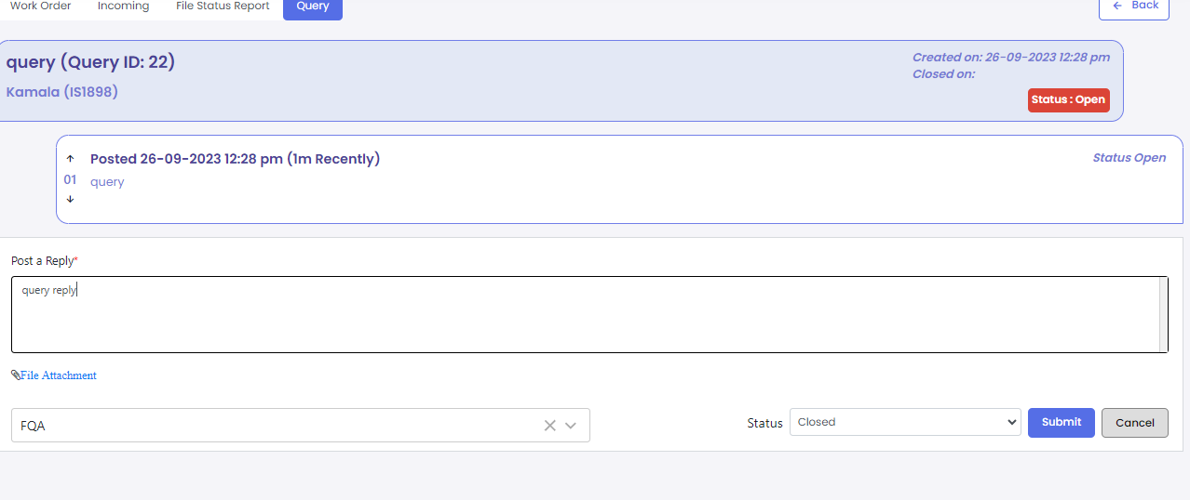

1. To create new query, click on the Add Query button on query tab page or the queries button in the View Task Information screen.
2. Choose required options and enter all mandatory fields.
3. Click on the save button to create the query or the cancel button to cancel the query creation.

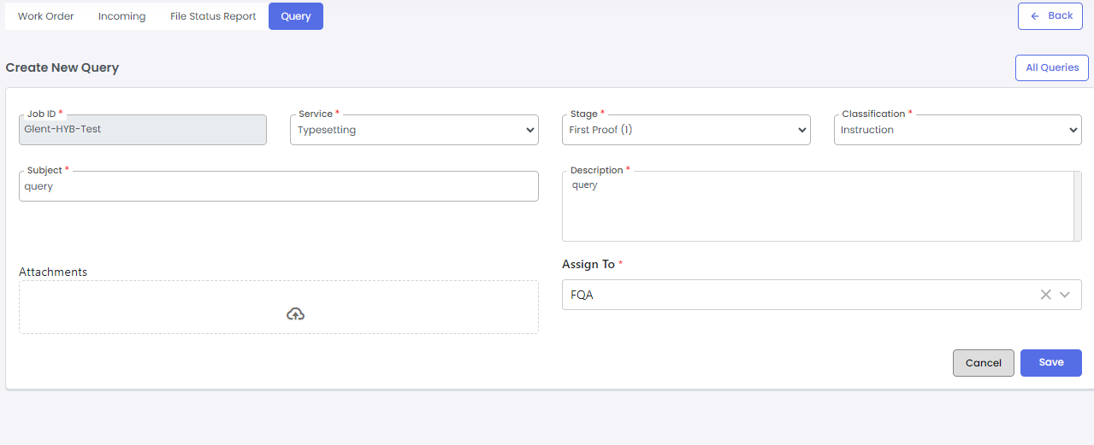

# 7. Workflow flowcharts

## Role wise workflow

Project Manager

Create new Work order*

Edit existing Work order details

Upload Work order specific instructions

Set due dates for stages*

Define services for the work order*



Incoming Inspection user

Upload files for incoming*

Update file details after incoming inspection*

Save files after incoming and start workflow*

Team Lead

Assign/ Reassign tasks to user

Edit UOM for UOM error tasks

Reset tasks from reset menu

Update file sequence using File Reordering menu

Claim/ View tasks from the User Task menu

Team Members

Raise/ Respond to queries if any

Perform Task action

(Save, Pending, Reject, Cancel)

Complete checklist if applicable

Execute tools and use software for work

Work on application files

|  |  |
| --- | --- |
| . | Project Management Executive |
|  | Incoming |
|  | Team lead |
|  | Team member. Will include various skilled users (Composer, Quality checking, Graphics, XML, etc) |
|  | General activities of user |
|  | Standalone activities applicable for the user |
|  | Parallel activities |
| * | Not applicable for automated workflows (CUP Journals, IOPP Journals) |

## Customer Onboarding workflow

**Production and Production Technology**

Finalize workflow requirements and tools

UAT

Provide sign-off for requirements documentation

Finalize customer specific requirements

Share requirements to Products team

**Product Management**

Prepare the requirements documentation

Review the workflow requirements documentation

Receive demo from Production technology for tools and software execution

Receive workflow and other requirements KT from Production technology

Setup Jira board and initiate sprint planning and grooming

Raise queries and clarifications to Production technology

Clarify queries to development and SQA

**Development**

UAT support

Receive requirements KT and get queries clarified from Products

Design workflow stages and activities in Camunda

Setup Customer Master data and Journal Master

Implement despatch module as per customer requirements

Enable FTP watcher and file upload/ download to FTP if applicable

Configure external/ internal email triggers against stages- activities

Setup user list based on skill and map it to activities

Enable on save and after save validations for stages- activities

Configure file input and output for stages-activities

Integrate other system with the workflow if applicable

Configure workflow tools and software

UAT support

**Development**

SQA Testing

SQA/ UAT Fixes

Go Live

|  |  |
| --- | --- |
| . | Production and Production technology |
|  | Product Management |
|  | Development team |
|  | Parallel activities |
|  | Page connector |

# iWMS user credentials

|  |  |  |  |  |
| --- | --- | --- | --- | --- |
| **Customer** | **IS Number** | **Name** | **Skill** | **Activity** |
| Emerald Journals | IS1872 | Subashini | Pre-editor | L1, L1QA |
| Emerald Journals | IS8496 | Pratima | Copy-Editor | L2,L2QA |
| Emerald Journals | IS5257 | STELLA.S | DCA | XML Conversion, Online QC, Package creation |
| Emerald Journals | IS6616 | Dinesh P | Composer | Corrections, Composing |
| Emerald Journals | IS7613 | Jayaseelan | QC | QC, Cross checking |
| Emerald Journals | IS6342 | Viknesh | FQA | FQA, |
| Emerald Journals | IS7823 | Sarala | Incoming | Incoming inspection |
| Emerald Journals | IS3960 | Kanchana | Lead | Give for overall activity |
| Emerald Journals | IS9308 | Abdul Aziz | PM | Collation, Despatch, Wait for Author Feedback |
| Emerald Journals | is8262 | Sakthivel Jegananthan | All access | All activities |
| Emerald Journals | IS9290 | UMAMAHESWARI CHELLADURAI | PM | Collation, Despatch, Wait for Author Feedback |
| Emerald Journals | IS8741 | Vinitha Djivadayalane | PM |
| Emerald Journals | IS051 | Thomasraj | PM | Collation, Despatch, Wait for Author Feedback |
|
|  | IS4615 | SRI HARI KUMAR | Project Manager | PM Dispatch, |
| CUP Books | Giff extraction |
|  | Giff extraction |
| CUP Books | IS1234 | ARUNA. S | TL |  |
| CUP Books | IS5103 | KAMALI.M | FQA | FQA, |
| CUP Books | IndexFQA, |
| CUP Books | Prelims FQA, |
| CUP Books | BookPDFCorsschecking, |
| CUP Books | Proof Reading , |
| CUP Books | Cross Checking, |
| CUP Books | Index cross checking, |
| CUP Books | PDF Compare with Previous PDF - revises stage, |
| CUP Books | Cross Checking - revises stage, |
| CUP Books | FQA - revises stage, |
| CUP Books | Index Cross Checking - revises stage, |
| CUP Books | Index FQA - revises stage, |
| CUP Books | Prelims FQA - revises stage, |
| CUP Books | Book Mergering Engine - revises stage, |
| CUP Books | Chapter Files Engine - revises stage, |
| CUP Books | Crop PDF Creation - revises stage, |
| CUP Books | PDF Compare Voucher - voucher stage, |
| CUP Books | PDF Compare POD - voucher stage, |
| CUP Books | Final FQA - voucher stage, |
| CUP Books | FQA Despatch - voucher proof,revises, |
| CUP Books | firstproof and elds |
| CUP Books | IS1898 | KAMALA.P | FTR, Composer,Template Developer | FTR Composing, |
| CUP Books | FTR Correction |
| CUP Books | Composing, |
| CUP Books | Correction in 3B2, |
| CUP Books | Index ID Generation, |
| CUP Books | Prelims Generation, |
| CUP Books | FirstProof Cover Upload, |
| CUP Books | Reloading Process, |
| CUP Books | Index FTR ID Generation, |
| CUP Books | ELDS Cover Upload, |
| CUP Books | Common - FP cover upload, |
| CUP Books | Book Merge Engine, |
| CUP Books | Chapter FilesIn Engine |
| CUP Books | FirstProof Cover Upload, |
| CUP Books | Extraction of XML - reloading stage & voucher, |
| CUP Books | Reloading Process - reloading stage, |
| CUP Books | Correction in 3B2- revises stage & voucher, |
| CUP Books | Extraction of XML - reloading stage, |
| CUP Books | FTR Correction - revises stage, |
| CUP Books | Index ID Generation - revises stage, |
| CUP Books | Index Compare - revises stage, |
| CUP Books | Index FTR ID Generation - revises stage, |
| CUP Books | Prelims Generation - revises stage, |
| CUP Books | Final PS Creation - voucher stage, |
| CUP Books | FTR correction - voucher stage, |
| CUP Books | Final PS Merge - voucher stage, |
| CUP Books | Revises PDF Creation - Voucher stage, |
| CUP Books | Giff Extraction - voucher , |
| CUP Books | Break up form generation - voucher |
| CUP Books | Smart PDF Generation - eld, |
| CUP Books | Smart PS Merge -eld, |
| CUP Books | ELD cover upload - eld, |
| CUP Books | smart metadata -eld, |
| CUP Books | smart pdf checking -eld, |
| CUP Books | Book Mergering - |
| CUP Books | IS7471 | KOWSALYA B | Incoming Inspection | Incoming Inspection, |
| CUP Books | CAMS Source Upload, |
| CUP Books | Index XML Upload, |
| CUP Books | Indexed Word upload, |
| CUP Books | Word PDF Upload, |
| CUP Books | Reloading XML upload - reloading stage, |
| CUP Books | IS4550 | POONGUZHALI. S | QC,FQA | FQA, |
| CUP Books | IndexFQA, |
| CUP Books | Prelims FQA, |
| CUP Books | BookPDFCorsschecking, |
| CUP Books | Proof Reading , |
| CUP Books | Cross Checking, |
| CUP Books | Index cross checking, |
| CUP Books | PDF Compare with Previous PDF - revises stage, |
| CUP Books | Cross Checking - revises stage, |
| CUP Books | FQA - revises stage, |
| CUP Books | Index Cross Checking - revises stage, |
| CUP Books | Index FQA - revises stage, |
| CUP Books | Prelims FQA - revises stage, |
| CUP Books | Book Mergering - revises stage, |
| CUP Books | Book Mergering Engine - revises stage, |
| CUP Books | Chapter Files Engine - revises stage, |
| CUP Books | Crop PDF Creation - revises stage, |
| CUP Books | PDF Compare Voucher - voucher stage, |
| CUP Books | PDF Compare POD - voucher stage, |
| CUP Books | Final FQA - voucher stage, |
| CUP Books | FQA Despatch - voucher proof,revises, |
| CUP Books | firstproof and elds |
| CUP Books | IS4289 | SANTHIYA.M | XML | Word ID generation, |
| CUP Books | Linking XML conversion, |
| CUP Books | XML conversion, |
| CUP Books | Batch Validation, |
| CUP Books | PC Online QC-QA, |
| CUP Books | PC Cover Image, |
| CUP Books | PC ePub & Mobi Generation, |
| CUP Books | Dispatch |
| CUP Books | Pre-Editing, |
| CUP Books | Link & Merge process, |
| CUP Books | FQA- typescript stage, |
| CUP Books | Merge-INI Creation - elds, |
| CUP Books | Elds Automation - elds, |
| CUP Books | Online QC-QA - elds, |
| CUP Books | ELD Cover image - elds, |
| CUP Books | ELDS ePub & Mobi Generation - elds, Deliverables Generation |
| CUP Books | Online QC-QA - elds, |
| CUP Books | ELD Cover image - elds, |
| CUP Books | ELDS ePub & Mobi Generation - elds, Deliverables Generation |
| CUP Books | IS6639 | MALARVIZHI R | XML | Word ID generation, |
| CUP Books | Linking XML conversion, |
| CUP Books | XML conversion, |
| CUP Books | Batch Validation, |
| CUP Books | PC Online QC-QA, |
| CUP Books | PC Cover Image, |
| CUP Books | PC ePub & Mobi Generation, |
| CUP Books | Dispatch, |
| CUP Books | Pre-Editing, |
| CUP Books | Link & Merge process, |
| CUP Books | FQA- typescript stage, |
| CUP Books | Merge-INI Creation - elds , |
| CUP Books | Elds Automation - elds, |
| CUP Books | Online QC-QA - elds, |
| CUP Books | ELD Cover image - elds, |
| CUP Books | ELDS ePub & Mobi Generation - elds, Deliverables Generation |
| CUP Books | IS7262 | HARIMANIKANDAN H | Graphics |  |
| CUP Journals | IS9952 | AbooBakker | PME | Work order creation, Collation, Despatch, PM Review |
| CUP Journals | IS7934 | Shakila Bhaskar | TE_Word/ Pre editor | L1, L1QA |
| CUP Journals | IS9627 | Silambarasan | XML | XML conversion and Online QC |
| CUP Journals | IS8436 | Rangasamy | QC/FQA | FQA, Crosschecking, QC |
| CUP Journals | IS8115 | Ramya | CE | L2, L2QA |
| CUP Journals | IS9683 | Durga | Incoming | Incoming |
| CUP Journals | IS8198 | Yamuna | Composing | iAutopage, Composing/ Correction |
| CUP Journals | IS7910 | Ganapathy | Graphics | Image Upload |
| CUP Journals | IS631 | Jayesh | Team Lead | Task assign |
| CUP Journals | IS7739 | Manibalan | Graphic Artist |  |
| IOPP Journals | IS5057 | SURIYA | INCOMING | Incoming |
| IOPP Journals | IS5207 | ARULPANDIAN. S | TL | Task assign/ reassign |
| IOPP Journals | IS5469 | PREMA A | COMPOSITOR | Compositon/Correction, iAutopage |
| IOPP Journals | IS7294 | THENMOZHI. S | TECHNICAL-WORD | L1, L1QA, Style-editing |
| IOPP Journals | IS7690 | MUTHULAKSHMI | DCA | XML Correction, Online QC, Package creation, epub conversion |
| IOPP Journals | IS7694 | ARUNA M | TECHNICAL-WORD | L1, L1QA, Style-editing |
| IOPP Journals | IS9717 | SANDIYA M | QUALITY CONTROLLER | Compare and QC, FQA |
| IOPP Journals | IS9536 | ANANTHAVALLI | COMPOSITOR | Compositon/Correction, iAutopage |
| IOPP Journals | IS9461 | BANUPRIYA | COMPOSITOR | Compositon/Correction, iAutopage |
| IOPP Journals | IS9245 | SURIYA R | COMPOSITOR | Compositon/Correction, iAutopage |
| IOPP Journals | IS9040 | SURIYA RAJ | COMPOSITOR | Compositon/Correction, iAutopage |
| IOPP Journals | IS9541 | KARTHIKEYAN L | COMPOSITOR | Compositon/Correction, iAutopage |
| IOPP Journals | IS8263 | BHOOMINATHAN K | TECHNICAL-LATEX/COMPOSITOR | L1, L1QA, Style-editing, Compositon/Correction, iAutopage |
| IOPP Journals | IS8505 | SOUNDARARAJAN | TECHNICAL-LATEX/COMPOSITOR | L1, L1QA, Style-editing, Compositon/Correction, iAutopage |
| IOPP Journals | IS7292 | PAVITHRA | FQA | Compare and QC, FQA |
| IOPP Journals | IS9390 | BARATH | GRAPHIC ARTIST | Image upload, conversion |
| IOPP Journals | IS9382 | PRAKASH S | GRAPHIC ARTIST | Image upload, conversion |
| IOPP Journals | IS8022 | IYANAR R | FQA | Compare and QC, FQA |
| IOPP Journals | IS8981 | GUKHAPRIYA | DCA | XML Correction, Online QC, Package creation, epub conversion |
| IOPP Journals | IS5700 | SATHIANATHAN R | TECHNICAL-LaTeX/TECHNICAL-WORD | L1, L1QA, Style-editing |
| IOPP Journals | IS9299 | SINDHUJA S | TECHNICAL-WORD | L1, L1QA, Style-editing |
| IOPP Journals | IS7889 | Brindha N | FQA | Compare and QC, FQA |
| IOPP Journals | IS9506 | SABITHA A | GRAPHIC ARTIST | Image upload, conversion |
| IOPP Journals | IS9720 | ANUSHA C | TECHNICAL-WORD | L1, L1QA, Style-editing |
| IOPP Journals | IS8307 | KAVITHA K | PROJECT MANAGEMENT TL | Despatch |